**Introduction to Surround**

**Surround** is introduced as a lightweight framework. It serves as a pipeline for machine learning in Python. What Surround is offering is flexibility and simplicity for the data scientists. Which aims to help them focus more on the problems and less on glue code.

**How it works**

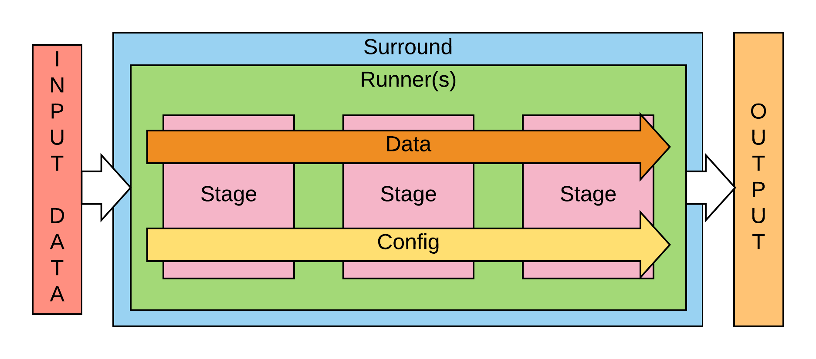

*Surround* can be a combination of stages or just one depending on the need of the user. The stages can be arranged in any order the user sees fit and these stages process and transform the input data into meaningful output data. The *surround data* is shareable between and contains information for each stage. What each stage does it read and process the surround data and put back the processed output for the next stage to use that data. This goes one till the final stage which gives us the meaningful output data.

While working with surround data the thing to keep in mind is that a user can create as many variable as he want but the four core variables that comes with surround data are stage_metadata, execution_time, errors and warnings.

*Surround stage* are used for data transformation. It’s the surround stages where the surround data are processed and modified. Each stage can be set to perform a number of actions which helps it process the input data to an extend that the output data of that stage can be used by the next stage. This goes on until the last stage which gives the user desired output.

The number of pipeline implementation is also in the hand of the user which helps him interchange between pipelines.